Module 1 Assignment: APA, Plagiarism, & Role Transition Articles



Submit by 2359 (CT) Saturday at the end of Module 1.
Name |  | Date:
Overview: “APA, Plagiarism, & Role Transition Articles”
In the Module 1 Assignment, you will view an APA Module to obtain information about writing in a professional style and in professional formats that are expected at the BSN level of the College of Nursing. After viewing the APA Module, you will submit an Attestation Statement Form. The reference on Scholarly Writing in your Resources will also provide tips on strengthening your professional writing skills. As part of scholarly writing, you must ensure proper citation for others’ work, including both direct quotations and paraphrased ideas, so you will study a Plagiarism Module for guidelines. Since your professional nursing experience may not have required you to regularly access professional libraries or databases, you will learn and practice the procedures for retrieving research articles. As a part of this assignment, you will select, cite, and summarize two research articles on the role transition from RN to BSN.

Resources
Use the following resources as you complete this Application assignment.
APA Modules:

1). UTA Library formatting guide: click the left-hand side menu under “home” to find resources and examples to help you. Please note, we are using the Professional Paper guidelines.
https://libguides.uta.edu/apa/home
2). Purdue Writing Center: https://owl.purdue.edu/owl/research_and_citation/apa_style/apa_formatting_and_style_guide/general_format.html

3). APA official website: https://apastyle.apa.org/style-grammar-guidelines

4). Plagiarism Module: complete this module and use the “Acknowledging Sources Quiz” score for the screen shot instructions in Part 2 of this assignment. (You will use this link for Part 2)

http://library.uta.edu/plagiarism/index.html

Refer also to your course readings and lectures as you complete the assignment.
Performance Objectives
  - Document use of online capabilities to locate APA and Plagiarism Modules.
  - Summarize and cite articles in APA format on the transition to professional nursing.
Rubric
Use this rubric to guide your work on the Module 1 Assignment, “APA, Plagiarism, & Role Transition Articles.”
Tasks  ⬇ | Accomplished | Proficient | Needs  Improvement
Part 1:  APA Module  (Total 30 points)  Part 2:  Plagiarism Model  (Total 10 points)  Part 3:  Articles on Role Transition  (Total 60 points) | Completes APA Module Attestation Form. (30 points)  Plagiarism module is completed and screen shot of score is embedded in this document.  (10 points)  Selects 2 articles and lists the APA references correctly – no errors.  (20 points)  Writes 2 summaries - one summary for each article. Each summary is 1 paragraph of 3-4 well-written, original sentences with no grammatical errors.  (40 points) | Partially completes APA Module Attestation Form. (25 points)  Plagiarism module score is listed, but screen shot is not embedded in this document. (5 points)  Selects at least 1 article and lists the APA references with no more than 4 errors.  (10 points)  Writes at least 1 summary for an article. The summary is 1 a paragraph of 3-4 original sentences with no more than 2 grammatical errors. (20 points) | Does not complete APA Module Attestation Form. (0 points)  Plagiarism module score is not reported, or is reported inaccurately. (0 points)  Selects 1 or no articles and/ or makes 4 or more errors. (0 points)  Both summaries are missing. (0 points), and/or the summaries have less than 3 sentences, and/or  3 or more grammatical errors. (0 points)

Part 1: APA Module

After viewing the APA information on page 1, complete the APA Attestation Statement Form.

APA FORMAT MODULE
ATTESTATION STATEMENT
I _____(YOUR NAME)_______________have gone to the APA module links provided.
By entering my name on this form electronically, I attest that I did indeed do the work required of me to meet the assignment of viewing the APA Format Module.

Name: _____________________________
E-mail: _____________________________
Date: ______________________________

Part 2: Plagiarism Module
- View the Plagiarism Module slide presentation (the 4th link under Resources on page 1). Click through all the slides, take the quiz, the next-to-last slide in the module displays your score.
- SPECIAL NOTE: When your score is displayed, use the “Print Screen*” feature of your computer to capture a screen shot, and paste it below: (Do not complete last slide of the presentation entitled “Send Your Score”) Follow the directions below and take a screen shot of the Score Page and paste in the text box below.

Directions for taking a screen shot:
* http://windows.microsoft.com/en-us/windows-vista/Take-a-screen-capture-print-screen

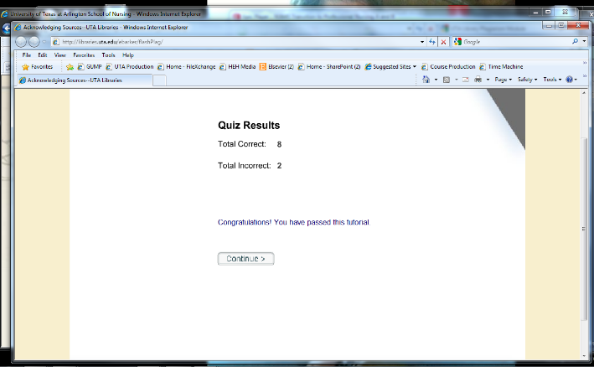
Example

Submit your screen shot as part of your Module 1 Assignments. DO NOT SEND THE SCREEN SHOT TO YOUR FACULTY.

HERE IS THE TEXT BOX TO COPY/PASTE YOUR SCREEN SHOT IN AND SUBMIT AS PART OF MODULE 1 ASSIGNMENTS.

Paste your Acknowledgement Statement here:

Part 3: Articles on Role Transition
NOTE FROM UTA LIBRARIANS: Internet Explorer and Foxfire are the browsers of choice when accessing UTA's online Library. You should NOT be accessing UTA E-reserves from your workplace or respective schools as firewall problems will typically prevent you from accessing our campus network.

- Access the UTA Online Library
- Search for two articles on the role transition from RN to BSN.
- For each article, complete the information below.
Article 1 reference: List entry in correct APA format.
Anbari, A. B. (2015). The RN to BSN transition: A qualitative systematic review. Global qualitative nursing research, 2, 2333393615614306.
Morris, A. H., & Faulk, D. (2007). Perspective transformation: Enhancing the development of professionalism in RN-to-BSN students. Journal of Nursing Education, 46(10), 445-451.

Brief summary paragraph (in your own words) of approximately 3-4 sentences:

Transitions from RN to BSN enable the nurses to navigate their careers and profession. Through the skills and knowledge acquired in the BSN enables the nurses to acquire better terms of employment. Also, it influences personal transformation in terms of emotions upon acquiring the BSN degree. This boots their nursing practice as it improves their critical thinking, improves their communication, and improves their patient outcome (Anbari 2015).

Article 2 reference: List entry in correct APA format.
Huston, C., Shovein, J., Damazo, B., & Fox, S. (2001). The RN-BSN bridge course: Transitioning the re-entry learner.
Spencer, J. (2008). Increasing RN-BSN enrollments: Facilitating articulation through curriculum reform. The Journal of Continuing Education in Nursing, 39(7), 307-313.

Brief summary paragraph (in your own words) of approximately 3-4 sentences:

Huston et al. (2001) says that the transition from RN to BSN plays a significant role in socialization. Socialization enables an individual to develop values and attitudes that enable him/her to relate better with others. These attitudes, values, skills, and knowledge enable nurses to interact well with the patients and thus provide better care. Also, the nurses acquire computer literacy that enables them to cope with the changing technology.

Submit this Assignment Document into Canvas for grading.

